Web copy
THE EXCHANGE
Real Work. Real Experience. Regional Talent.
The Exchange is a regional, employer-driven marketplace that connects businesses with early-career tech talent through applied work-based learning opportunities.
Through internships, short-term roles, and project-based engagements, The Exchange helps candidates build the real-world experience that makes skills marketable — while giving employers a practical way to support and shape the next generation of tech talent in Fairfield County.
This is not a job board, staffing service, or résumé database. It is a coordinated pathway for meaningful, time-bound work experiences that benefit both employers and emerging talent.
Why The Exchange
Early-career talent in our region is eager, trained, and ready to contribute, but too often lacks access to the applied experience employers look for.
At the same time, many businesses have real projects, operational needs, and emerging skills challenges that could become meaningful learning opportunities with the right structure and support.
The Exchange is designed to make that connection easier, more equitable, and more aligned with regional workforce needs.
Who This Is For
Businesses
Create real work-based learning opportunities that help early-career talent build skills while supporting your organization’s project needs.
Businesses can submit internships, short-term roles, or project-based engagements in areas such as software development, data and analytics, cybersecurity, cloud and infrastructure, digital marketing technology, product and UX, and IT support.
Opportunities should be scoped, time-bound, and designed around clear deliverables. Employers define the project, timeline, skills focus, supervision structure, and work environment.
What Businesses Can Do
- Submit a project, internship, or short-term role
- Work with validated, regionally connected candidates
- Help define the skills and experience early-career talent needs
- Build relationships with emerging local talent
- Contribute to a stronger, more accessible regional tech pipeline
What The Exchange Provides
- Candidate matching and coordination
- Initial review of opportunity scope and readiness
- Support sharing opportunities with regional partners
- A structured process for feedback and learning
- No obligation to hire at the end of the engagement
<<SUBMIT AN OPPORTUNITY>>
Applicants
Build hands-on experience through real projects with regional employers.
The Exchange is for early-career talent, students, recent graduates, program completers, and career changers who are ready to apply their skills in a professional setting.
Candidates do not apply directly to employers through The Exchange. Instead, the Exchange team reviews candidate interest, skills, readiness, availability, and alignment with available opportunities.
What Applicants Can Do
- Share your skills, interests, and availability
- Identify the type of work experience you want to build
- Be considered for internships, projects, or short-term roles
- Gain applied experience connected to real employer needs
- Build confidence, networks, and career readiness
What The Exchange Looks For
- Technical skills or training in a tech or tech-enabled field
- Interest in applied, hands-on work
- Readiness to participate in a professional environment
- Availability that aligns with employer opportunities
- Openness to feedback, learning, and collaboration
<<EXPRESS INTEREST>>
Opportunity Examples
The Exchange supports applied projects that build skills and create value for participating businesses.
Examples may include:
Business intelligence dashboard development
Security policy review or vulnerability scan
Marketing analytics and automation setup
Internal workflow automation
Customer-facing feature development
Help desk process improvement
Cloud migration or monitoring support
User research, wireframing, or product testing
A Good Fit for The Exchange
The Exchange is a strong fit for employers that have a defined project or task, can assign someone to supervise and provide feedback, and are interested in building a relationship with early-career talent.
It is not designed for employers looking only for low-cost labor, undefined general help, indefinite staffing, or work with no clear objectives or timeline.
Ready to Get Started?
Businesses can submit an opportunity for review.
Applicants can express interest in being considered for future opportunities.
Participation begins with a simple intake form and a conversation with The Exchange team.
FOR BUSINESSES: SUBMIT AN OPPORTUNITY
FOR APPLICANTS: EXPRESS INTEREST

Workflow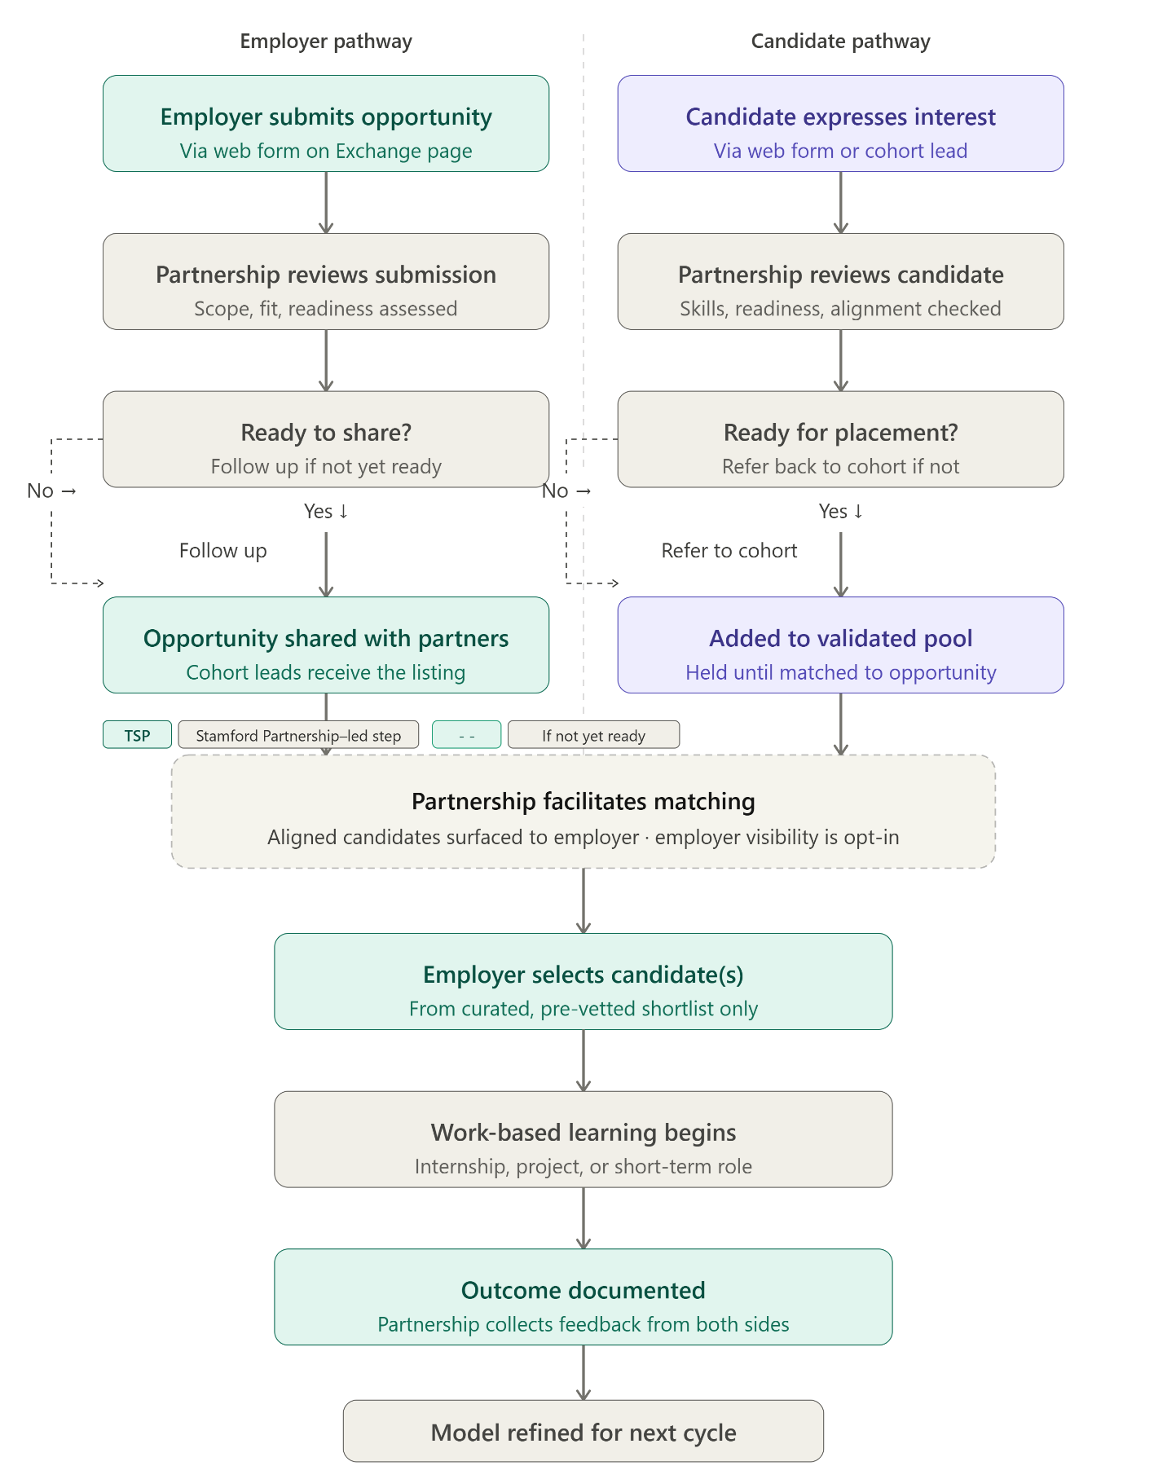

Employer Opportunity Intake Fields
Section | Field | Type | Required? | Options / Notes
Organization | Company name | Text | Yes | Organization name
Organization | Primary contact name | Text | Yes | Full name
Organization | Contact email | Email | Yes | Work email
Organization | Company address | Text | Yes | City, CT
Opportunity details | Name of opportunity / project | Text | Yes | Example: Data Dashboard Sprint, IT Support Internship
Opportunity details | Type of engagement | Radio | Yes | Internship; Project-based; Short-term role
Opportunity details | Goal of opportunity | Long text | Yes | What should the candidate accomplish or learn?
Opportunity details | Day-to-day candidate activities | Long text | Yes | Typical tasks and activities
Opportunity details | Technical skills required or desired | Text | Yes | Example: Python, Azure, Tableau
Opportunity details | Business knowledge or background desired | Text | No | Example: healthcare, finance, operations
Opportunity details | Duration | Text | Yes | Example: 6 weeks, 3 months
Opportunity details | Expected hours per week | Text | Yes | Example: 10–15 hrs/week
Opportunity details | Work location | Dropdown | Yes | In-person; Hybrid; Remote
Opportunity details | Project stage | Dropdown | No | New project; Ongoing project; Exploratory / undefined
Supervision & environment | Candidate supervisor | Text | Yes | Name and role
Supervision & environment | Level of team interaction expected | Dropdown | No | Mostly independent; Regular team collaboration; High interaction / client-facing
Supervision & environment | Laptop / equipment | Radio | No | Candidate brings own; We provide one
Supervision & environment | Hosted an intern or project resource before? | Radio | No | Yes; No, first time
Supervision & environment | Workplace culture or environment | Text | No | Example: fast-paced startup, collaborative nonprofit
Internal — Exchange team only | Is compensation available? | Dropdown | No | Yes — paid; Unpaid / credit only; Open to discussion; Seeking Hub financial support
Internal — Exchange team only | Possibility of extended or follow-on work? | Dropdown | No | Yes, likely; Possible; No; Unknown
Internal — Exchange team only | Preferred visibility on platform | Radio | No | Name company publicly; Keep anonymous initially
Internal — Exchange team only | Ideal start date or timeframe | Text | No | Example: September 2026
Internal — Exchange team only | Additional ideal candidate notes | Text | No | Anything else that would make a candidate ideal
Candidate Interest Form Fields
Section | Field | Type | Required? | Options / Notes
About you | Full name | Text | Yes | Candidate name
About you | Email address | Email | Yes | Candidate email
About you | Phone number | Text | No | Optional
About you | Town or city | Text | Yes | Example: Stamford, Bridgeport
Education & training | Current or most recent school or program | Text | Yes | Example: CT State, UConn, Synchrony Skills Academy
Education & training | Field of study or program focus | Text | Yes | Example: Cybersecurity, Data Analytics, IT
Education & training | Enrollment status | Dropdown | No | Currently enrolled; Recently completed program; Graduate within 2 years; Career changer / returning learner
Education & training | Expected or actual completion date | Text | No | Example: May 2026, already completed
Skills & interests | Technical skills developed | Text | Yes | Example: Python, SQL, Excel, networking, help desk
Skills & interests | Desired type of work | Long text | Yes | Problems, projects, or environments of interest
Skills & interests | Skills to build through experience | Long text | Yes | Hands-on experience desired
Skills & interests | Industries or sectors of interest | Text | No | Example: healthcare IT, finance, government, nonprofit
Availability & logistics | Available start date | Text | Yes | Example: September 2026, immediately
Availability & logistics | Hours available per week | Dropdown | Yes | Up to 10 hrs/week; 10–20 hrs/week; 20+ hrs/week; Full-time
Availability & logistics | Work location preference | Radio | No | In-person; Hybrid; Remote; Open to any
Availability & logistics | Reliable transportation or remote access | Radio | No | Yes; Transportation is a barrier; Need remote setup support
Supporting materials | LinkedIn profile | Text | No | LinkedIn URL
Supporting materials | Resume | File | Yes | Upload
Supporting materials | GitHub or portfolio | Text | No | GitHub or portfolio URL
Supporting materials | Additional notes | Long text | No | Context, goals, barriers, or matching notes

Copy Out take:
How It Works
1. Employers Submit Opportunities
Businesses share a project, internship, or short-term role through The Exchange intake form. The Exchange team reviews the opportunity for scope, fit, readiness, supervision, timeline, and candidate alignment.
2. Candidates Express Interest
Applicants submit information about their skills, training background, interests, availability, work preferences, and supporting materials.
3. The Exchange Reviews for Fit
The Exchange team reviews both employer opportunities and candidate profiles to determine readiness and alignment. If an opportunity or candidate is not yet ready, the team may follow up before moving forward.
4. Matching Begins
Aligned candidates are surfaced to employers from a curated, pre-vetted pool. Employer visibility on the platform is opt-in, and candidate referrals are based on fit.
5. Work-Based Learning Begins
Once a match is confirmed, the employer and candidate begin the internship, project, or short-term role. Engagements are structured around clear expectations, supervision, and deliverables.
6. Outcomes Are Documented
The Exchange collects feedback from both sides to understand what worked, what can improve, and how the model should evolve for future cycles.

